Transformation:

1. Split images url by delimiter(|)
2. Removed all other col except the first one image url col
3. Replaced all null values by blank in image url col
4. Removed blank rows from image url col
5. Split category by lowerToUpper case, then

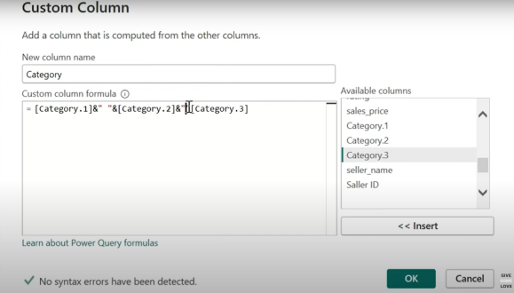

Or just merge with a space in between - using merge feature

Apply and close

Visualization:  
  
1.  : used this slicer on Category Field(drag and drop over the table in category)

**Format Visualization** :



1. remove blank entries using data transformation
2. Call out values -> Label -> ON
3. In field add Product Name

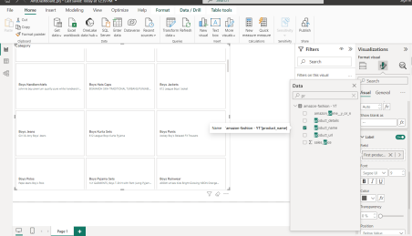

1. Close Label go to Images,
   1. Add large1(img col) to the Field
   2. Image fit = fit, position = left, ignore padding off
2. Close Images go to layout
   1. Set rows =8, col= 1
3. Set the css for all